

ANALYSIS DOCUMENT

FOR INFORMATION

DEVELOPMENT

SYSTEM -

USE CASE DIAGRAM

Project Phase 3

Take One movie Theatre Ticketing System

 | GROUP 19
Johané le Roux | 31614744
Christopher Slaghuis | 31713858
Jean Marx | 32313845
Reinhardt Nel | 27327884
James Uys | 28461789

Use Case Diagram Phase 3 Group 19

Contents

Use-case Glossary 2

Use-case Diagram 3

Marking Guide 4

1 | P a g e
Use Case Diagram Phase 3 Group 19

Use-case Glossary

Use Case Name | Use Case Description | Participating Actors
 |  | and Roles
Maintain Client | The event where a new client will be added to | Administrator(s)
 | the system, the details of an existing client
 | changes or an existing client is removed
Maintain Movie | The event where a new movie will be added to | Administrator(s)
 | the system, the details of an existing movie | Employee
 | changes or an existing movie is removed
Maintain Movie | The event where a new schedule will be added | Administrator(s)
Schedule | to the system, the details of an existing schedule | Employee
 | changes or an existing schedule is removed
Maintain Genres | The event where a new genre will be added to | Administrator(s)
 | the system, the details of an existing genre
 | changes or an existing genre is removed
Maintain Special | The even where a new special occasion will be | Administrator(s)
Occasions | added to the system, the details of an existing | Employee
 | special occasion changes or an existing special
 | occasion is removed
Sell Tickets | This use case describes the event in which a | Administrator(s)
 | ticket is sold to a client | Employee

2 | P a g e
Use Case Diagram Phase 3 Group 19

Use-case Diagram
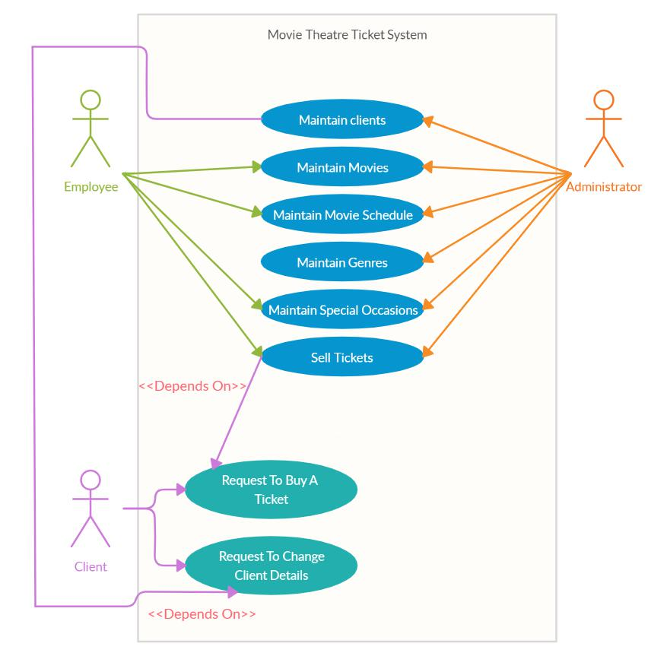

3 | P a g e
Use Case Diagram Phase 3 Group 19

Marking Guide

CMPG213 Marking Guide for Analysis Document 2020

Group Number: |  | 19
Members: | Johané le Roux |  | Student No: 31614744
 | Christopher Slaghuis |  | 31713858
 | Jean Marx |  | 32313845
 | Reinhardt Nel |  | 27327884
 | James Uys |  | 28461789

System to implement: |  |  | Take One Movie Theater
 |  |  | Item | Maximum | Group’s
 |  |  |  | Mark | Mark
 | Project scope (Updated from previous documents and specific) |  |  | 5
 | Use-case diagram (must include association relationships and |  |  | 15
 | at least one <<depends on>> relationship)
 | • | Use-cases
 | • | Actors
 | • | Associations
 | • | <<depends on>> relationship
 | • Frame and system name
 | Fully attributed data model (example Fig 8-16 P 297) |  |  | 20
 | • | Entities
 | • | Attributes
 | • | Primary keys
 | • | Foreign keys
 | • Relationships (weak/strong, verb, cardinality)
 | • | 3NF
 | Process models (Only primitive diagrams, i.e. lowest level of |  |  | 30
 | detail)
 | • | Agents
 | • | Processes
 | • | Data Stores
 | • | Data flows
 | Scope, Use-case diagram, data models and process models |  |  | 10
 | are integrated, e.g.
 | • dataflows contain attributes of entities,
 | • all actors appear as agents in process models,
 | • all use cases appear as processes in process models
 | • all entities appear as data stores in process models
 | • all use-cases refer to entities in data model
 |  |  |  |  | 4 | P a g e

Use Case Diagram |  | Phase 3 |  | Group 19
 | TOTAL |  | 80

Comments:

_________________________________________________________

_________________________________________________________

_________________________________________________________

_________________________________________________________

5 | P a g e

